Overall plot beatsheet:
Chapter 1: Introductions
We start knowing nothing
The photographer asks introductory questions
The characters introduce themselves
The photographer asks a series of ice breakers
Each character answers one at a time

Chapter 2: your story

Chapter 3: The cutting?
The photographer asks everyone why they are here
They all gave a variety a reasons some of which are the photographers acclaim, the fact that the message of this series resonates with them, free time, personal connection to the photographer
The ultimate point of this is to make it known that all these people self harm
The photographer asks about the first time they self harmed
They answer one at a time
The photographer asks them why they self harm
They answer one at a time
The photographer asks where they self harm
They answer one at a time
The photographer asks how long they’ve self harmed
They answer one at a time
The photographer asks how they self harm
They answer one at a time
Some object to this particular question
The photographer asks if they still self harm
All but theresa say yes

Chapter 4: why were really here

You find out that all the characters are planning on killing themselves
This interview is their final message to the world
The interviewer asks why they want to die
They answer one at a time
The interviewer asks if there is anything they want to say
They answer one at a time
At this point is the only choice in the game
Either convince them against it
Or understand their reasoning and accept that they will do it
Youre given a score at the end for how many you saved
The title of the game changes based on how many you save

Green sections appear as black screens with questions like in old black and white movies
Black sections appear as the respective scene for the specified character
Characters beatsheet Chapter 1:
Mel:
Introduces her self as an unemployed hikimori
Photographer asks what that means
Explanation
Photographer asks how old they are
Mel says 22
Photographer remarks that shes awfully young
Mel says its a matter of perspective
The photographer says hes gonna start with a rapid fire icebreaker questionnaire
The Photographer asks what their favourite meal is
Mel says chicken strips and rice with tabasco
The photographer asks what their favourite cloud is
Mel says the wispy kind
The photographer remarks that those are called cirrus clouds and that theyre primarily made of ice crystals
The photographer asks if they would put lettuce on a hotdog
Mel remarks that that is disgusting and mentions shes a picky eater and wont even eat hotdog, and that she subsists primarily on chicken strips
The photographer asks if they take dancing seriously
Mel says she tries to have fun and that requires that you don't really take it seriously, she only dances when shes alone
The photographer asks how they feel about graffiti
Mel likes graffiti and thinks its art. She would like to do it but doesn't leave the house
The photographer asks how many seasons their favourite show is
6 season- community
The photographer asks if they ever had a musical phase
Mel used to play the piano as a kid but never really pursued it
The Photographer asks if they post on social media or just lurk
Definitely just lurk
The photographer asks if they dream and if so do they have nightmares
Sleeps very soundly for most of the day
The photographer asks what age they think would be the best in their lives
Mel says 12 because that's when she had the most friends
The photographer asks how many hours of sleep they get
14 to 16
The photographer asks what their saddest song is
The moon or I felt your shape by the microphones
The photographer asks if they ever have a fantasy of running away somewhere far
and leaving everything behind
Where would they go, it would be the same everywhere
The photographer asks if they see images in their head
Mel says she sees her memories replay in her head
The photographer asks if they believe in an objective reality
Mel says that theres no such thing as an objective reality, that reality is shaped by people perception.
The photographer asks how often they ask questions
Not often, in fact she doesn't speak much, this is the most shes spoken to someone in a year

Diego:
Diego introduces himself as an auditor and salary man (derogatory)
Photographer asks how old they are
Diego says 32
The photographer says hes gonna start with a rapid fire icebreaker questionnaire
The Photographer asks what their favourite meal is
Pho from the vietnamese place around his office
The photographer asks what their favourite cloud is
I wanna say the fluffy ones?
The photographer asks if they would put lettuce on a hotdog
Diego doesn't see anything wrong with that if youre into that sort of thing
The photographer asks if they take dancing seriously
Diego doesn't dance hes too busy at the office to go to night clubs
The photographer asks how they feel about graffiti
Diego isnt a fan, mentions how he doesn't like the graffiti around his office neighbourhood
The photographer asks how many seasons their favourite show is
Friends 10 seasons
The photographer asks if they ever had a musical phase
Diego was a theatre kid growing up and sang in musicals
The Photographer asks if they post on social media or just lurk
Diego occasionally posts
The photographer asks if they dream and if so do they have nightmares
Diego doesn't dream just blackness
The photographer asks what age they think would be the best in their lives
45 he could have saved enough money to move to malaysia
The photographer asks how many hours of sleep they get
6 at best
The photographer asks what their saddest song is
Diego is thrown back by this question
He thinks
He says Wasting my Young years by london grammar
The photographer asks if they ever have a fantasy of running away somewhere far and leaving everything behind
More about malaysia
The photographer asks if they see images in their head
They day dream, where they usually see what happens
The photographer asks if they believe in an objective reality
Yeah i would say so
The photographer asks how often they ask questions
All the time for work not much outside that

Theo:
Photographer asks how old they are
Theo says 19
The photographer remarks that he was the only one he had qualms including due to his age
Theo says he knows and is glad to be included
The photographer says hes gonna start with a rapid fire icebreaker questionnaire
The Photographer asks what their favourite meal is
Indomie ramen and a little lime
The photographer asks what their favourite cloud is
Theos a big fan of big thunder clouds but only from far away
The photographer asks if they would put lettuce on a hotdog
Theo objects and says it doesn't go with ketchup, which is essential on a hotdog
The photographer asks if they take dancing seriously
Theo says he doesn't really dance
The photographer asks how they feel about graffiti
Theo says he loves graffiti and used to do it all the time
The photographer asks how many seasons their favourite show is
Shameless, 11 seasons
The photographer asks if they ever had a musical phase
Plays guitar
The Photographer asks if they post on social media or just lurk
Definitely a lurker
The photographer asks if they dream and if so do they have nightmares
Theo smokes too much weed to dream
The photographer asks what age they think would be the best in their lives
Must be 65 when youre retired and can just read all day
The photographer asks how many hours of sleep they get
A decent 9 or 10
The photographer asks what their saddest song is
Car seat headrest I know that im asleep I hope that youre awake
The photographer asks if they ever have a fantasy of running away somewhere far and leaving everything behind
He says sometimes he imagines going somewhere far one day without telling anyone
The photographer asks if they see images in their head
They see things outside their head
The photographer asks if they believe in an objective reality
No everything is subjective
The photographer asks how often they ask questions
Not enough prefers to say quiet to not ask stupid questions

Pat:
Photographer asks how old they are
Pat says 23
The photographer says hes gonna start with a rapid fire icebreaker questionnaire
The Photographer asks what their favourite meal is
Anything but hospital food hes not too picky

The photographer asks what their favourite cloud is
Streaks in the sky
The photographer asks if they would put lettuce on a hotdog
Yeah no problem
The photographer asks if they take dancing seriously
Pat doesn't dance
The photographer asks how they feel about graffiti
Pat thinks some of it is art like cool text doesn't like scribbles
The photographer asks how many seasons their favourite show is
Doctor who 26 seasons
The photographer asks if they ever had a musical phase
Pat has always been more interested in the visual arts
The Photographer asks if they post on social media or just lurk
Pat doesn't even have a phone
The photographer asks if they dream and if so do they have nightmares
Pat dreams lucidly
The photographer asks what age they think would be the best in their lives
Pat says 45 still young enough to enjoy life old enough to have your shit together
The photographer asks how many hours of sleep they get
12 hours nothing to do but sleep in the ward
The photographer asks what their saddest song is
Nutshell - Alice in Chains
The photographer asks if they ever have a fantasy of running away somewhere far and leaving everything behind
Would like to get out after the ward
The photographer asks if they see images in their head
Pat is a schizophrenic and sees things
The photographer asks if they believe in an objective reality
He cant reconcile that with his illness
The photographer asks how often they ask questions
Always

Alex:
Photographer asks how old they are
Alex says 27
The photographer says hes gonna start with a rapid fire icebreaker questionnaire
The Photographer asks what their favourite meal is
Alex says ice cream
The photographer asks what their favourite cloud is
The ones that look like sheets in the sky
The photographer asks if they would put lettuce on a hotdog
Alex says she always does
This is the first time P has heard someone admit that
The photographer asks if they take dancing seriously
Alex hasnt danced since the incident
The photographer asks how they feel about graffiti
Alex used to graffiti with her best friend
The photographer asks how many seasons their favourite show is
2 seasons Andor
The photographer asks if they ever had a musical phase
Alex used to be in a band in middle school
The Photographer asks if they post on social media or just lurk
Alex used to post quite frequently
The photographer asks if they dream and if so do they have nightmares
Alex has nightmares every night
The photographer asks what age they think would be the best in their lives
Alex had the most fun in her early 20s
The photographer asks how many hours of sleep they get
A solid 8 but in bursts of 4 or 5 hours
The photographer asks what their saddest song is
Into My Arms - Nick Cave and the Bad Seeds
The photographer asks if they ever have a fantasy of running away somewhere far and leaving everything behind
She used to but not anymore
The photographer asks if they see images in their head
Yeah she sees her friend sometimes in her head
The photographer asks if they believe in an objective reality
Hopes there are alternate universes
The photographer asks how often they ask questions
Alex used to ask questions all the time

Theresa:
Photographer asks how old they are
Theresa says 68
The photographer says hes gonna start with a rapid fire icebreaker questionnaire
The Photographer asks what their favourite meal is
hot tomato soup and bread
The photographer asks what their favourite cloud is
Theresa remarks that that's a nice question
She says cirrus stratus
The photographer says someone had already said that but he had forgotten what it was called
The photographer asks if they would put lettuce on a hotdog
Theresa doesn't eat hotdogs
The photographer asks if they take dancing seriously
Theresa loves dancing and takes it very serious
The photographer asks how they feel about graffiti
Theresa doesn't like it
The photographer asks how many seasons their favourite show is
Downton Abbey 6 seasons
The photographer asks if they ever had a musical phase
Theresa still plays the piano
The Photographer asks if they post on social media or just lurk
Theresa doesn't know what that means
The photographer asks if they dream and if so do they have nightmares
Theresa dreams sometimes of a family
The photographer asks what age they think would be the best in their lives
Theresa enjoys her 70’s
The photographer asks how many hours of sleep they get
Theresa gets 5 or 6 hours of sleep a night
The photographer asks what their saddest song is
I fall in love so easily Chet Baker
The photographer asks if they ever have a fantasy of running away somewhere far and leaving everything behind
Theresa feels too old for that
The photographer asks if they see images in their head
Theresa used have a very active imagination that faded with age
The photographer asks if they believe in an objective reality
Theresa believes that there is an objective reality that we subjectively experience
The photographer asks how often they ask questions
Theresa says she asks plenty of questions

Photographer (universal) beats:
Photographer asks how old they are
The photographer says hes gonna start with a rapid fire icebreaker questionnaire
The Photographer asks what their favourite meal is
The photographer asks what their favourite cloud is
The photographer asks if they would put lettuce on a hotdog
The photographer asks if they take dancing seriously
The photographer asks how they feel about graffiti
The photographer asks how many seasons their favourite show is
The photographer asks if they ever had a musical phase
The Photographer asks if they post on social media or just lurk
The photographer asks if they dream and if so do they have nightmares
The photographer asks what age they think would be the best in their lives
The photographer asks how many hours of sleep they get
The photographer asks what their saddest song is
The photographer asks if they ever have a fantasy of running away somewhere far and leaving everything behind
The photographer asks if they see images in their head
The photographer asks if they believe in an objective reality
The photographer asks how often they ask questions

Starting Text:
Each shown individually
This is a series of interviews I conducted in fall 2026
I have catalogued these interviews in the form of a game
Your role in this game is to be an interviewer
The role of an interviewer is to lead the conversation and listen.
Remember that you are only an interviewer
Nothing you do will change this story

Chapters:
Each bolded line is text infront of a black screen with a ding sound effect when it first appears
When the character is speaking they are speaking in their own environment.
{options} tags indicate a point in the script where the user selects ONE of the options and moves on
Redtags are placeholder scenes to be marked with place holder and the scene id
Blue text appears non traditionally (Not in the bottom left) and instead takes up more screen space and is placed over the scene in a way that fills the negative space creatively
Introductions:
P:
Let’s get started
Why don't you start with your name, your age, and your occupation?
Mel:
Hi, I’m Mel, I'm 23…
P: That's awfully young.
Mel: That’s a matter of perspective.
P: and what is it that you do
Mel:
I’m an unemployed hikikomori
P: a hakuku what
Mel: I don't leave my apartment
Diego:
Hey, I’m Diego, I'm 32, and I’m a software developer
Theo:
Yo, it's Theo, I'm 19 and I'm a college student and a dishwasher on the weekends
P: We necessarily have younger people because the population of this series is young
But you were the only one i had objections with
You know including you in the series
Theo:
No I’m glad you did
I think it's important
Pat:
I’m Pat, I'm 22, and I don't really do anything since I've moved into the hospital
Alex:
Hey, I’m Alex, and I’m 27
Theresa:
Hello, I’m Theresa. I'm 76 years old, and I’m a retired secretary.
P:
So I usually find that people don't like talking about what we're gonna be talking about
Especially with strangers
So I wanna start with some icebreakers
You know, just some questions before we get into the real…
Meat and potatoes
Theo:
Bit odd to call it meat and potatoes
But go on
P:
What is your go-to meal?
Mel:
Chicken Strips, rice, and Tabasco.
Pretty plain but its what I like.
Diego:
There’s place around the corner,
Pho Pasteur, it's called
Great Pho
Theo:
-shot of bowl of noodles over a white skybox-(Scene ID:cutaways/ramen)
Oh let me put you on
You take an Indomie packet
Indomie is this indonesian brand of instant noodles
Anyway you take the indomie and you crush it up
Add just enough water to cover the top
Leave uncovered and then add a little lime
And youve got the best noodles on the planet
Pat:
I’m not too picky
Anything but this fucking hospital food
Alex:
Im gonna be a bit extra here
Ice cream
Theresa:
Hmm
HMMM
AH
Hot tomato soup and a nice slice of toasted sour dough bread

What is your favourite type of cloud?
In this section photos of the clouds show up instead of the usual scenes
cloud photos can be found in photos/clouds/{charname}.jpg
Mel:
You know those wispy ones really high up?
P:
Those are called cirrus clouds
They're the highest clouds and are made up of ice crystals mainly
Mel:
That's cool, I guess?
Deigo:
I don't know
The fluffy ones I guess
Sorry, that's just something I don't really care about.
Theo:
Oooh, good question,
I love a big plume-y rain cloud
I love the rain in general
Pat: I love the streaky clouds
That cover the whole sky
Alex:
I love one big grey sky
A little drizzle i perfect too
Theresa:
I love a clear day
A perfectly blue sky
Nothing better

Would you put lettuce on a hot dog?
Mel:
That sounds so gross.
{options}
[option 1]
P: Why's that?
Mel: I’m a pretty picky eater, so I don't really do green.
[option 2]
P: What do you eat then, other than chicken strips and rice?
Mel: I literally don't eat anything else
I have it for breakfast, lunch, and dinner
Well I only eat once per day but you get my point.
Diego:
Sure, if you're into that sort of thing
I don't judge
Theo:
Nah no way
Doesn't go with ketchup
Ketchup's an essential condiment for a hotdog
Pat:
Eh I don't really see anything wrong with it
Wouldnt put it on my hotdog
Alex:
Oh yeah always
People think im strange for it
Then again, my favourite food is ice cream
P: you’re the first person I met who puts lettuce on a hotdog
That's pretty special
Theresa:
I don't put anything on hotdogs
But that's because i don't eat hot dogs

Do you take dancing seriously?
Mel:
I don't think so. I try to have fun and that requires me not to take it so seriously
But i guess im serious about my unseriousness…
So do with that what you will
Diego:
I don't really dance
Its not because I can’t or I’m against it or something
I just spend most of my weekends at the office
Theo:
I’m too cool for dancing
Maybe too hot too
Pat:
I don't dance
Alex:
I used to dance
I don't any more
After you know…
P: We’ll get into that soon enough
Theresa:
Oh dead serious
I love dancing
I used to do flamenco when these hips were still real

How do you feel about graffiti?
Mel:
Well its art ofcourse
Id love to do something like that
I guess i could graffiti the walls but that's no fun
Diego:
Oh, not a fan
I find that most of the time it's just some garbage tag
Just look around the neighbourhood
Theo:
Hell yeah, man,
I used to do that all the time back in high school
Don't really anymore
{options}
[option 1]
P: Why is that?
Theo:
Because I get charged as an adult now, silly
[option 2]
P: What kinda stuff did you throw up?
Theo:
Tags mostly
Pat: Oh, I hate tags
But if it's a cool artwork, I approve
Alex:
Yeah, I used to graffiti all the time
Theresa:
Not a fan
I guess if I was younger, I wouldn't mind so much

How many seasons is your favourite show?
Mel:
6 seasons… didn’t really like the last two
Community is what it was called
Diego:
Friends, 10 seasons
It's pretty mindless, but it keeps me going
Theo:
Shameless…
11 seasons
Pat: Doctor Who, 26 seasons
It’s all I watch in here basically
Alex:
2 seasons, Andor
P: Short and sweet
That makes sense
Theresa:
Oh sadly too short
6 seasons, its called Downton Abbey

Have you ever had a musical phase?
Mel:
I used to play the piano as a kid
My mom would take me to these lessons
I never really enjoyed it
I couldn't figure out how to move my hands independently, so I never got to play the stuff I wanted to
Diego:
Yeah, actually…
I was a theatre kid growing up
P: What kind of plays did you do?
Just silly middle school stuff
I did The Addams Family once
I played Gomez
Singing and dancing and all that
Theo:
I play the guitar
Try to anyway
Sold it though
Pat:
Nah, I’ve always been more interested in the visual arts
Used to paint before I came here
Alex:
Yeah I used to be in a band in Middle School
The Gob Knoblins
Such a stupid fucking name
It was my friend *****’s idea
Theresa:
I still play the piano whenever i get the chance
Although im not as good as i once was

Do you post on social media, or just lurk?
Mel:
Post! Oh god no, I just scroll reels all day.
Diego:
The occasional story post, yeah
Theo:
All the time
I’m killing it on there
Pat:
I don't even have a phone
Alex:
Yeah, I used to post stories all the time
I'd curate little posts too every now and then
Theresa:
I don't know what lurk means
P: You know, like just look at people's posts
Theresa:
Oh no I post pictures of my grandkids and family gatherings and such

How many hours of sleep do you get?
Mel:
14
Sometimes 16
I like sleeping through most of the day and waking up at around 2:30
{options}
[option 1]
P: Whys that?
Mel: At around 4:30
-shot of silhouette of houses and a blue background-(Scene ID:cutaways/bluehour)

Still a ways from sunset
Theres an hour
That's blue
No one is awake at this time, not the degenerates or the early risers
Its just me
[option 2]
-still in Mel's place-
P: Seems a bit excessive, no?
Mel:
Again, that's a matter of opinion
Diego:
Ha, I get 6 at best
Sometimes 4 if it's crunch season
Theo:
A decent 9 or 10
All my classes are later on in the day
Pat:
I sleep a good twelve hours
They give you some pretty heavy stuff to help you sleep
And its all there is to do around here
Unless you wanna do the same 3 puzzles over and over
Alex:
I sleep weird
I get like 8 9 hours
But in spurts of 4 or 5 hours
Theresa:
Not irregular for a woman my age
5 or 6

Do you dream? Do you have nightmares?
Mel:
No, not really. I sleep a lot, so maybe that's why
Diego:
Pure black, that's all I see
Theo:
No way jose
Smoke too much for that
P:smoke what
Theo: The carts bro
Like disposable weed pens
Pat:
-shot of lunar surface-(Scene ID: cutaways/moon)
I have pretty vivid dreams
I’ve been having this recurring one
Im on the moon
And theres this well
I jump in the well
And i wake up every time
Just before i hit the bottom
Alex:
Nightmares every time i sleep
Its why i sleep so short
I usually jolt awake when it gets to intense
As you can tell…
This causes me alot of anxiety
Its crazy
{options}
[option 1]
P: what kinda nightmares?
Alex: Oh you know the usual stuff
A lot about *****
A lot about whats to come
P: youre afraid of whats to come?
Alex: Shouldn't I be
[option 2]
P: I’m sorry, that sounds horrible
Alex: It's okay; it's not all bad
I’m unfazed by the most absurd things
That's a perk
Theresa:
I dream of my family sometimes
I don't see them much, so they show up in my dreams
Grandmotherhood is weird like that

What age do you think was or will be the happiest?
Mel:
12 I think
I had a lot of friends back then
P: you don't anymore?
Mel: Just the one
His name is Andy
Lives in a different country though so we just talk on the phone
That's what I do with most of my day.
Diego: the way I see it if i could just make it to 45
Then i would have enough saved
To go back home
And enjoy the low cost of living haha
Theo:
Oh gotta be like 65/70
That's the age where all you get to do
Is take downers and read
Pat: hmm
45 i reckon
Old enough to have your shit together
Youndg enough to enjoy your body still
Yeah 45
Alex:
Oh, I had a lot of fun in my early twenties
Its gotta be that
Theresa:
You know im enjoying my 70s
Its peaceful
It feels like a conclusion

What is your saddest song recommendation?
Mel:
Oh easy,[hyperlink to song starts] The Moon by The Microphones [hyper link end]
Actually maybe its [hyperlink to song start] The Moon by The Microphones [hyper link end]
Diego:
That’s a bit on the nose, isn’t it
Hmm lets see
Id say [hyperlink to song start] wasting my young years by london grammar [hyper link end]
Diego:
I was just listening to it this morning
its [hyperlink to song start] Car seat headrest I know that im asleep I hope that youre awake[hyper link end]
Pat: [hyperlink to song start] Alice in Chains, nutshell[hyper link end]
Alex: Oh i could cry at the thought of this song
[hyperlink to song start]Into my arms, nick cave[hyper link end]
Theresa:
The most beautiful voice youll ever hear is in this song
It's [hyperlink start] Chet Baker I fall in love to easily [hyperlink end]
Do you ever fantasise about running away somewhere far and leaving everything behind?
Mel:
What would be the point
I’d be an unemployed hikikomori anywhere in the world
Diego:
Yeah, of course, sometimes I think about moving back home
{options}
[option 1]
P: Where's home
Diego: somewhere far away
There's a lot of nice beaches
Things are relatively cheap
Its always sunny
[option 2]
Diego:
Well, there's a reason I live here and not there
Lets just say that
Theo:
Oh I would love to disappear one day
Just vanish without telling anyone
Move into a cabin by the lake in the woods
That's the life
Pat:
Yeah I think that's my only option
Start somewhere new after the hospital
Do it right this time
Alex:
I used to
I wanted to run away somewhere when i was younger
Even had it all planned out
I was gonna hit all the national parks on the way
P: what happened to the plan
Alex: The person I was gonna do it with killed themselves
Oh
I’m sorry
Let’s move on
Theresa:
Oh, I'm too old for that
And my family
No i couldnt do that
P: strange
Theresa:
What?
P: Nothing.
Do you see images or things in your head?
Mel:
Sometimes I see my memories really vividly in my head
Does that count?
Diego:
I day dream a lot and those can get pretty dissociative
Almost like im in there you know
Theo:
Nah cant even put an apple in my minds eye
P: Sorry
Pat:
I’m a schizophrenic
So I see a lot
All the time
Alex:
Yeah sometimes i see *****
Its weird
Its good but its weird
P: its good?
Alex: Yeah, it's good
Theresa:
I have a very active imagination
Most of the day is spent in a day dream

Do you believe in an objective reality?
Mel:
No, of course not,
Reality isn’t some absolute thing
There are a million versions of reality
It all depends on our perception
Who's to say which one is the correct one
If there is a correct one at all
Diego:
Yeah I guess
Like something happened you know
I don't really get the question
Theo:
Nah the way i see it
Everyones living in their own versions of reality
Whats real for one person might be fake to another
Pat:
When youre a schizophrenic
Its hard to believe in anything objective
Everything comes through warped
Alex:
I think every decision spawns its own little pocket universe
Isnt that cool?!
Theresa:
Oooh questions like that go a bit over my head
Sorry dear

How often do you ask questions?
Mel:
Cant say all that often
I don't really speak much to anyone
Hard to ask questions
Diego:
All the time for work
Not much outside of that
Theo:
Better to stay quiet
You don't wanna look foolish now
Pat:
It’s all i do in here other than sleep
Ask people about their experiences
Were alot like that in that way
Theresa:
Probably not as much you with your job
But yes I ask plenty of questions
Mainly to my grandkids

Mel:
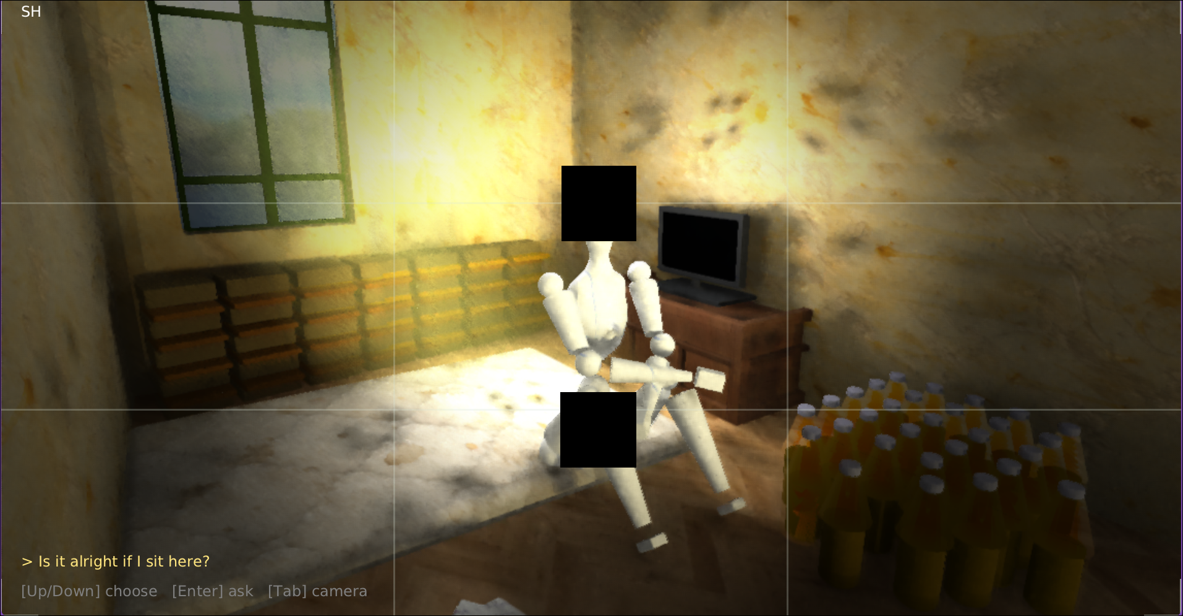

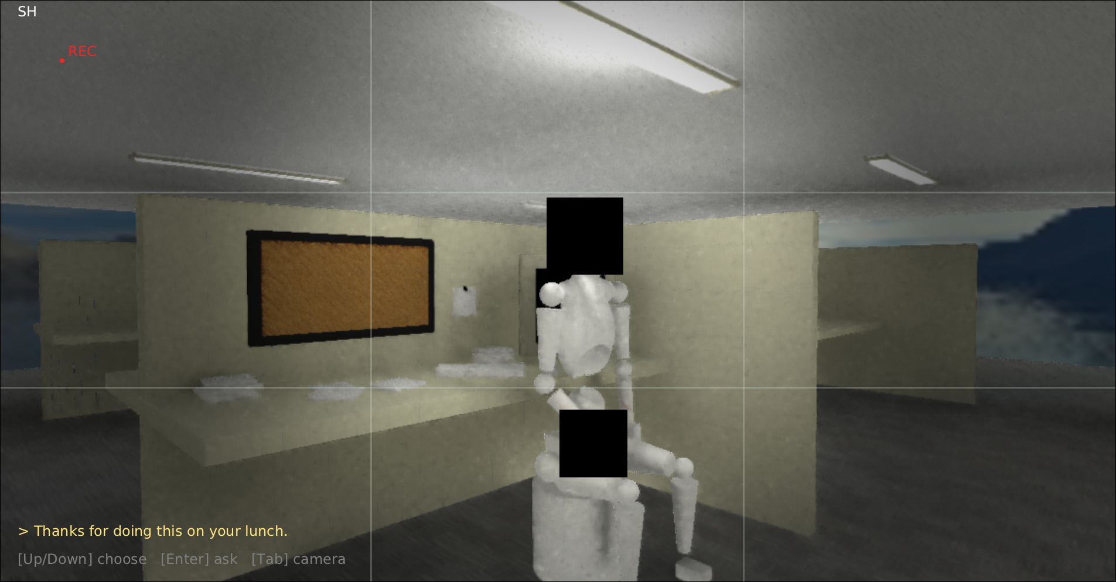
Diego

Theo
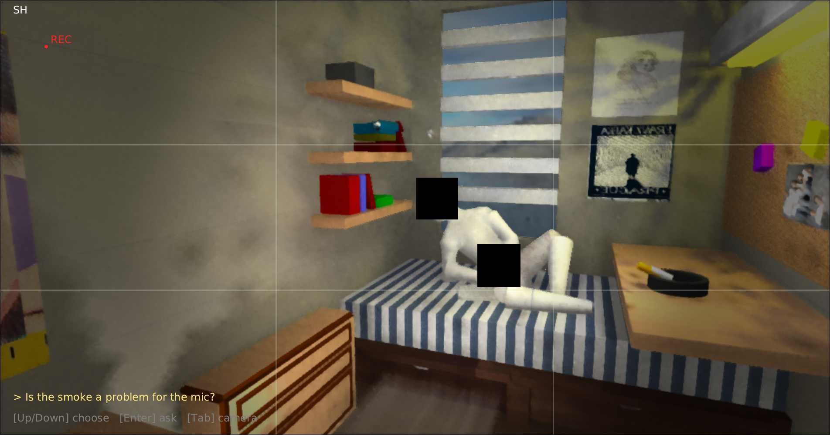

Pat

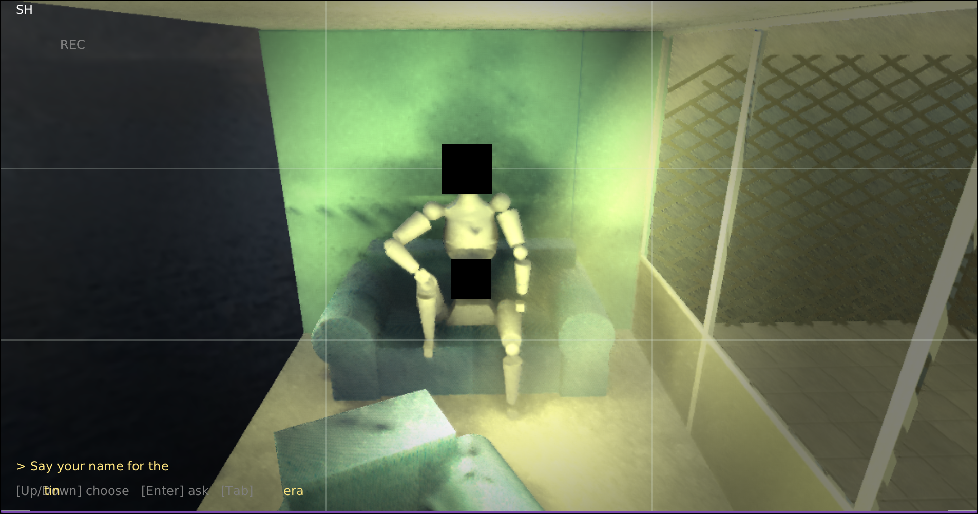
Theresa
`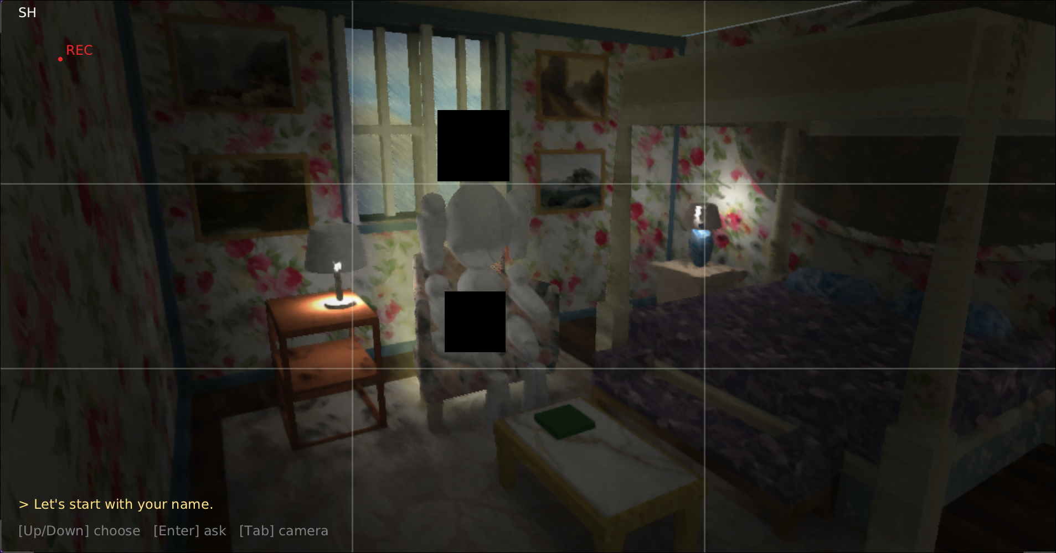

Alex

